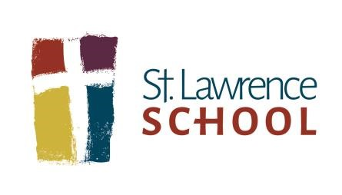
Please label with your child’s name:
Two pocket plastic folders
- 1 red (ELA)
- 1 blue (Math)
- 1 green (Science/Health)
- 1 yellow (Social Studies)
- 1 student’s choice (take home folder)
Supplies
- 9 x 12 Spiral bound sketch book (Art)
- 1 set of headphones labeled with name (No cordless headphones, please.)
- 1 supply case
- 24 pack of crayons
- 12 pack of markers
- 1 pair of scissors
- 1 composition notebook

Please do not label these supplies:
- 2 yellow highlighters
- 2 packs of number 2 pencils
- 2 black expo markers
- 4 pack of glue sticks
- 1 black fine tip sharpie (Art)
- 2 boxes of tissues

20
2
5
-
202
6

Fifth

Grade

Supply List

1000 North Greece Road • Rochester, NY 14626-1031 • 585.225.3870 Fax 585.225.1336 www.stlawrenceschool.org

